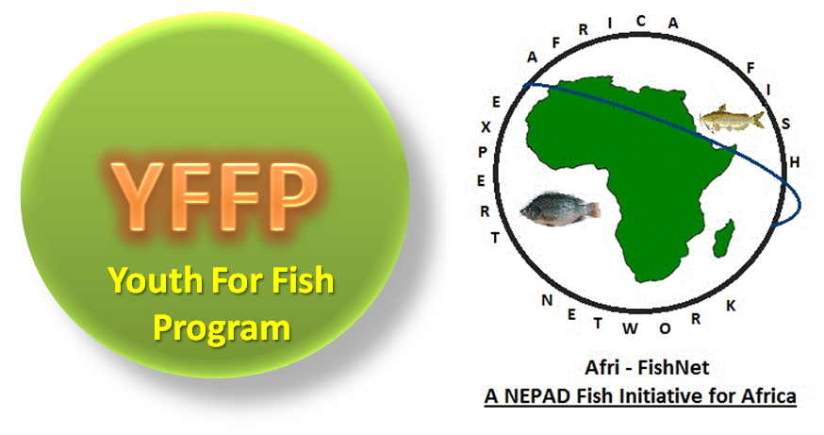

ESSAY COMPETTITION!
“How to Fully Engage the Youth in Enhancing Fisheries and Aquaculture in Sub Saharan Africa”

Bunda College (Lilongwe University of Agriculture and Natural Resources-LUANAR) in partnership with NEPAD (Through the NEPAD Regional Fish Node at Bunda), Department of Fisheries, National Commission of Science and Technology (NCST) will this year host a National Conference on Aquaculture and Fisheries in Malawi. The National Conference will be held at Sun n' Sand Holiday Resort, Malawi between 6-8th March, 2013 under the theme 'Aquaculture & Fisheries for Socio-Economic Growth'.

This national conference will provide a platform where all players ranging from policy makers, research institutions and implementing agencies engage in discussions and learn on the initiatives being undertaken within the sector.

As part of capacity building and bringing a youth perspective to the development of aquaculture and fisheries, Youth For Fish Program (YFFP) is inviting youths (15-35years) to participate in an essay competition on “How to Fully Engage the Youth in Enhancing Fisheries and Aquaculture in Sub Saharan Africa”. African Fisheries Experts Network (Afri-fishnet) will sponsor winning candidates (travel, accommodation and meals) to attend and present their essay at the conference.

Submit your 5-10 paged essay now! to yffp@afri-fishnet.org by 13th February, 2013

Remember to get registered as a member of YFFP before submitting your essay.
Download membership application form www.nepadsanbiofishnode.org/Opportunities.php and return to yffp@afri-fishnet.org

